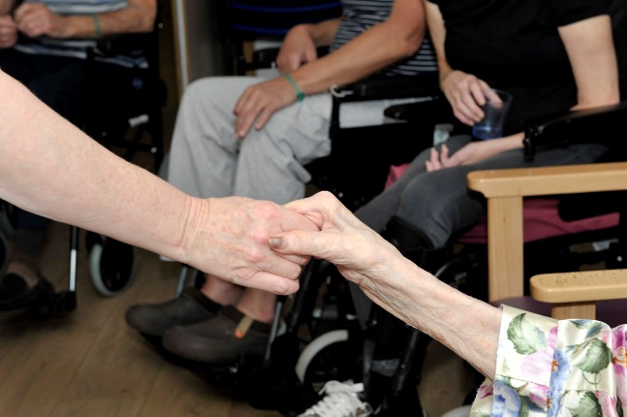
“It has made me more confident, especially knowing I had the support of staff at the time” (Participant quote)
…”The project provides opportunities for people affected by stroke to rebuild their lives….” Ross Evans Head of Stroke Support South Wales
Case Study
Rubicon’s programme for Stroke Survivors
A dance ‘movement to music’ project exploring how we could develop and grow a programme that enhances the activity, mood, confidence and social experience of Stroke survivors Stroke Rehabilitation Centre (SRC) at UHL.
Title : Developing a dance programme for Stroke Survivors
Authors and Organisation: Author:
Sharon Teear

Organisation:
Rubicon Dance
Kathryn Williams, Director
Sharon Teear, Dance Development Co-ordinator
Anwen Davies, Dance Leader
https://rubicondance.co.uk

Partnership: Arts Team
Melanie Wotton, Arts-in Health Project Manager,
Simone Joslyn, Head of Arts and Cardiff & Vale Health Charity, Cardiff and Vale University Health Board (CAVUHB) https://cardiffandvale.art
UHL Stroke Rehabilitation Centre, SRC (Dr. Susan White, Claire Butterworth, Clinical Specialist Physiotherapist in Stroke, Chris Rees)
http://www.cardiffandvaleuhb.wales.nhs.uk/stroke-rehabilitation-centre
Sereana Chima:
Speech and Language Therapy assistant ( SALT assistant )
*Poster of her research found on https://cardiffandvale.art

Stroke Association: https://www.stroke.org.uk/ Sarah Lee, Project Development Manager Lauren Heath the Volunteering and Community Steps Officer Community Steps Programme: https://www.stroke.org.uk/finding-support/community-steps-programme

Abbreviations:
UHL University Hospital Llandough
SRC Stroke Rehabilitation Centre
CAVUHB Cardiff and Vale University health board
SALT Speech and Language Therapy
WWTP Wales Wide Training Programme

Publication date: 07/09/19
Categories: Movement, Dance, Music, Creative Expression
Supporters and Funders: Funders:
- May 2018 The 6 week pilot project was originally supported by Gwanwyn, Age Cymru and the Cardiff and Vale Health charity.
- From Sept 19th 2018- April 10th 2019 Rubicon secured funds via Fusion (WAG) and the SRC Endowment funds to continue the project for an additional 24 weeks whilst sourcing future funding.
- May 2019 – May 2020 Funding via the Millennium Stadium Charitable Trust allowing us to embed a continuous programme at the SRC
- April 2019-Sept 2019 Funding by Stroke Association Development grant for tasters in the community
- September 2019-July 2019 Funding by Cardiff and Vale Health Charity to run an established Community Session for Stroke survivors

Supporters:
With additional practical support helping to refer/direct Stroke survivors into the community session.
from:-
Sara Lee and Lauren Heath from the Stroke Association, Community Steps Programme
Joanne Davies from Independent Living Services,
Huw Davies Service Lead in Community Neuro Rehabilitation and Early Supportive Discharge for Stroke
Joanna Murison, OT from John Pathy Day Hospital

150 word Summary:

In the Age Cymru Gwanwyn Festival 05/18 a pilot project called ‘Flow’ was established by the Arts Team CAVUHB in partnership with Rubicon and the SRC at UHL. We aimed to explore how dance could support stroke survivors by enhancing mood, movement and social interaction through shared creative activity. We developed and up scaled the project drawing on the expertise of all stakeholders. We started small, increasing opportunities for activity. An increase in movement activity, socialisation and mood was evidenced via attendance figures, feedback, observations and mood scores. This enabled us to source additional funding, develop and embed this practice within SRC. We then shared best practice at conferences and training events. Rubicon are now working with the Stroke Association to establish a community dance session that stroke survivors can be referred into once discharged. Due the project’s success Rubicon are developing further sessions in various CAVUHB wards with the Arts Team.

Aims:
To develop a dance programme that supports people in their life after stroke through addressing issues in confidence, inactivity, social isolation and low mood.

Outputs:
1 hour dance session per week. The set up and content was flexible and responded to patient needs. After the success of the six week pilot Rubicon sourced funding to continue.

May 2018-July 2019:- 40 sessions, 345 total attendances, Average of 9 attendances per session

Sharing:
A SALT assistant evidenced the positive impact the sessions had on patients mood with a poster and presentation of her research at the Welsh Stroke Conference 04/07/19 *. SRC also displayed a poster on how they use creative activities including sessions by Rubicon to address inactivity and social isolation.

Rubicon presented at WWTP Best Practice Forum for other dance practitioners across Wales explaining how we developed this work.

Outcomes:
Increased socialisation, confidence, activity and enhanced mood were evidenced in the SALT assistants’ research, the Arts team and Rubicon’s evaluations, feedback of staff, patients and family.

Cost:
The weekly 1-hour session for the pilot project cost £50. With an average of 10 participants per session this equates to £5 per person. This cost is likely to increase with further sessions, to include evaluation and administration costs.

Quality Indicators:
Dedicated engagement from all key stakeholders:-the Arts Team, SRC staff, Rubicon and the Stroke Association, helped us achieve our outcomes. The Arts team were fundamental in setting up the pilot. The SRC enthusiastic support and clear debriefing of the patients’ needs enabled the session to thrive. Rubicon’s motivating sessions and ability to develop them was vital to the programs growth.

Evaluation
Evaluation methods included record of attendance figures, quotes, feedback, observations, mapping exercises, all of which were completed at various stages. The stroke unit staff observed positive mood changes among participants noting the difference before and after the sessions. Positive mood changes were recorded by the SALT assistant after every session over a 10 week research period.

‘…we were excited to progress this work with Rubicon to continue an offer into the local community. The Stroke Community Steps project provides opportunities for people affected by stroke to rebuild their lives... through this partnership we are taking the expertise of both organisations to reach more people and increase support in Cardiff and Vale’. (Ross Evans Head of Stroke Support South Wales)
Wider impacts:
Weekly dance sessions are now embedded practice at SRC. Rubicon are now working with the Stroke Association with the financial support of the Arts team to establish a community dance session that patients can be referred into once discharged to address feeling isolated at home.
Due to the success of this project we are now continuing our work with the Arts team, broadening our impact within the hospital settings, developing new sessions in six wards for dementia patients and elderly care with more projects in the pipeline.

TAGS

Stroke; recovery; NHS; dance; art; health; well-being; socialisation; movement

…………………………………………………………………………………………………………

